**EASTERN WASHINGTON UNIVERSITY**

**ADVANCEMENT PROGRAMMING EXAM WEBSITE**

**DATABASE DOCUMENTATION**

**Senior Capstone Class 2017**

**Instructor: Tom Capaul**

**Team: Tu Nguyen, Aaron Griffis, Andy Robinson**

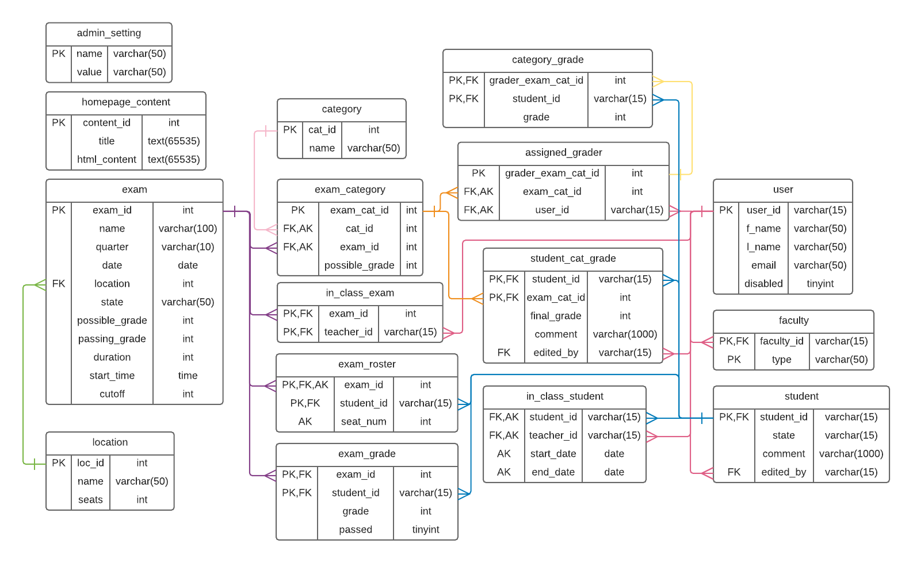

admin_setting

Used to store system-wide configurations that can be changed by an admin.

* catGraderLimit: the maximum number of graders allowed to be assigned to a category of an APE.
* contactEmail & contactName: the contact information that is included in emails sent by the system. This does NOT affect the contact info shown on the home page. Admins must use the homepage editor to change that info.
* pointDiffRange: the allowable difference between scores given by different graders to the same student in the same category. If the difference is within this range, the scores are automatically averaged, otherwise, the score is flagged and an admin must enter the grade manually.
* *Start & *End: the beginning and end dates of each quarter. These are used for dynamically determining the quarter based on a given date throughout the system. These values should be changed each year.

# assigned_grader

Used to keep track of graders assigned to categories of APE exams.

* grader_exam_cat_id: used to uniquely identify a record using a single attribute.
* exam_cat_id: the ID of the exam-category combination to which the grader is assigned. Refers to the exam_category table.
* user_id: the ID of the user (grader) who is being assigned. Refers to the user table.

# category

Used to store options for categories to include in an APE.

* cat_id: used to uniquely identify a record using a single attribute.
* name: the name of the category.

# category_grade

Used to store individual grades given by graders to students for a specific category. These are NOT the final category grades for the students.

* grader_exam_cat_id: the ID of the combination of grader, exam, and category for which this grade is given. Refers to the assigned_grader table.
* student_id: the ID of the student to whom the grade is given. Refers to student table.
* grade: the grade given to the student.

# exam

Used to store info about each APE

* exam_id: used to uniquely identify a record using a single attribute.
* name: the name of the exam.

quarter: the quarter in which the exam is given.

* date: the date of the exam.
* location: the ID of the location of the exam. Refers to the location table.
* state: the state of the exam. Can be "Open", "In_Progress", "Grading", "Archived", or "Hidden".
* possible_grade: the maximum grade that can be earned on the exam.
* passing_grade: the grade that must be earned to pass the exam.
* duration: the length of the exam in hours.
* start_time: the time at which the exam begins.
* cutoff: specifies when to disallow registration for an exam. The value is the number of hours before the beginning of the exam.

# exam_category

Used to store info about the categories of specific exams.

* exam_cat_id: used to uniquely identify a record using a single attribute.
* cat_id: the ID of the category in the exam. Refers to category table.
* exam_id: the ID of the exam the category is in. Refers to exam table.
* possible_grade: the maximum grade that can be earned in this category for this exam. The sum of the possible grades for each category in an exam is the possible grade for the exam.

# exam_grade

Used to store final APE grades given to students.

* exam_id: the ID of the exam for which the grade is given. Refers to the exam table.
* student_id: the ID of the student to whom the grade is given. Refers to the student table.
* grade: the grade given to the student.
* passed: whether or not the student passed the exam. 1 --> passed, 0 --> failed.

# exam_roster

Used to keep track of students registered for specific exams.

* exam_id: the ID of the exam for which the student is registered. Refers to the exam table.
* student_id: the ID of the student registered for the exam. Refers to the student table.
* seat_num: the seat assigned to the student for the exam.

# faculty

Used to store account types of faculty users.

* faculty_id: the ID of the faculty user. Refers to the user table.
* type: the account type of the user. Can be "Admin", "Teacher", "Grader", or "System". There should only be one "System" entry, with ID 999999.

# homepage_content

Used to store the HTML content of the homepage visible to students and those who are not logged in.

* content_id: used to uniquely identify a record using a single attribute.
* title: the title of the info section in the homepage.
* html_content: the HTML content of the info section in the homepage.

# in_class_exam

Used to keep track of exams that are in-class (practice APEs, CHIMPs, 211 finals, etc).

* exam_id: the ID of the exam that is in-class. Refers to exam table.
* teacher_id: the ID of the teacher of the class. Refers to user table.

# in_class_student

Used to keep track of students in teachers' classes.

* student_id: the ID of the student in the class. Refers to the student table.
* teacher_id: the ID of the class's teacher. Refers to the user table.
* start_date & end_date: the time frame that the student is in the teacher's class. Should correspond to start and end dates of a quarter.

# location

Used to keep track of locations in which APEs can be given.

* loc_id: used to uniquely identify a record using a single attribute.
* name: the name of the location (e.g. CEB 207)
* seats: the number of seats available in the location.

# student

Used to store information on the state of student users.

* student_id: the ID of the student user. Refers to the student table.
* state: the status of the student's account. Can be "Ready", "Registered", "Passed", or "Blocked".
* comment: the required comment given by an admin or teacher (for in-class students) who changes a student's state. This will be NULL if the student's state has not been manually changed.
* edited_by: the ID of the user who manually edited the student's state. If the state has not been manually edited, the ID will be 999999 (system ID). Refers to the user table.

# student_cat_grade

Used to store the final grades for students for specific categories of specific exams.

* student_id: the ID of the student who received the grade. Refers to the student table.
* exam_cat_id: the ID of the exam-category combination for which the grade was given. Refers to the exam_category table.
* final_grade: the grade given.

comment: the required comment given by an admin or teacher (for in-class exams) who manually changes/enters the grade. This will be NULL if the grade was automatically calculated by the system.

* edited_by: the ID of the user who manually edited the grade. If the grade was generated by the system, the ID will be 999999 (system ID). Refers to the user table.

# user

Used to store info for all users in the system.

* user_id: the EWU ID of the user.
* f_name: the first name of the user.
* l_name: the last name of the user.
* email: the user's email address.
* disabled: whether or not the user's account is disabled, which would prevent them from accessing the website. This is generally meant for faculty who no longer work for EWU.

1 --> disabled, 0 --> enabled/active.